LoraTester1 Assembly Notes

# Enclosure Shell Assembly Order

1. Check if all supports are clean and removed. Use a twist drill bit by hand to clean out any supports in holes.
2. Use a 7mm drill bit to clean up SMA connector hole.
3. Check OLED window fit, apply glue to edges of acrylic and reinsert into place
4. Check button plate fit, apply glue to edges and insert into place. Additional glue around inside edges if desired.
5. Insert 7 brass fasteners into shell using a 40w soldering iron for heat and the flattening technique.   
   <https://hackaday.com/2019/02/28/threading-3d-printed-parts-how-to-use-heat-set-inserts/>

# Lid Assembly order

1. Insert 3 brass fasteners into lid using a 40w soldering iron for heat and the flattening technique.   
   <https://hackaday.com/2019/02/28/threading-3d-printed-parts-how-to-use-heat-set-inserts/>
2. If the lid EPDM gasket is not cut, use the lasercut stencil to trace out the profile of the gasket, and cut with an xacto-style blade or scalpel.   
   Use repeated shallow passes.
3. Ensure fit of lid gasket, and glue into position using Loctite 406.

# PCB Insertion

1. Note- There is a notch in the upper portion of the shell to push the PCB into while inserting the SMA connector

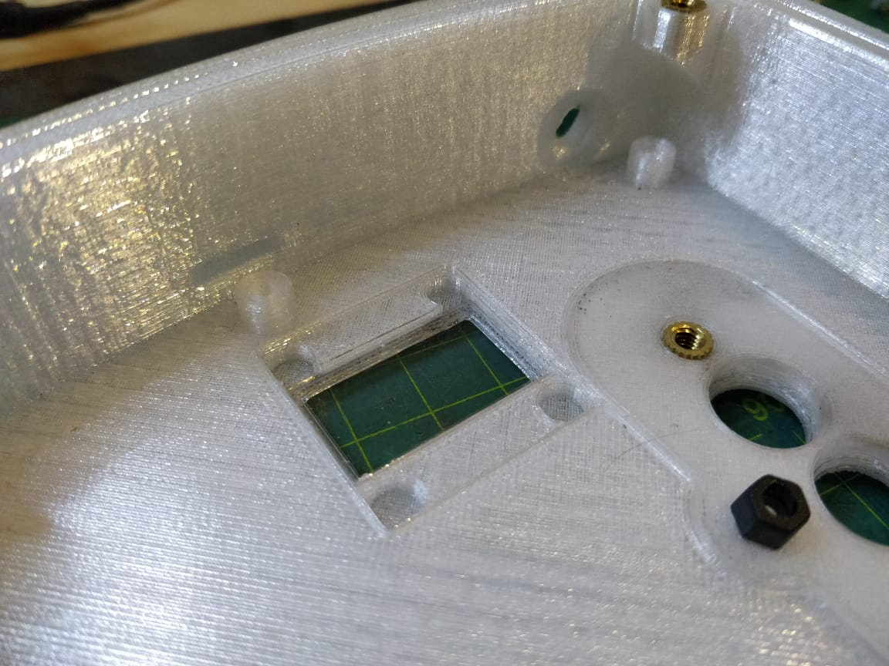

1. Align PCB corner with notch as indicated, and align SMA connector with SMA connector hole, and gently twist into position.

Ensure switch caps are properly aligned with the holes while twisting into place.

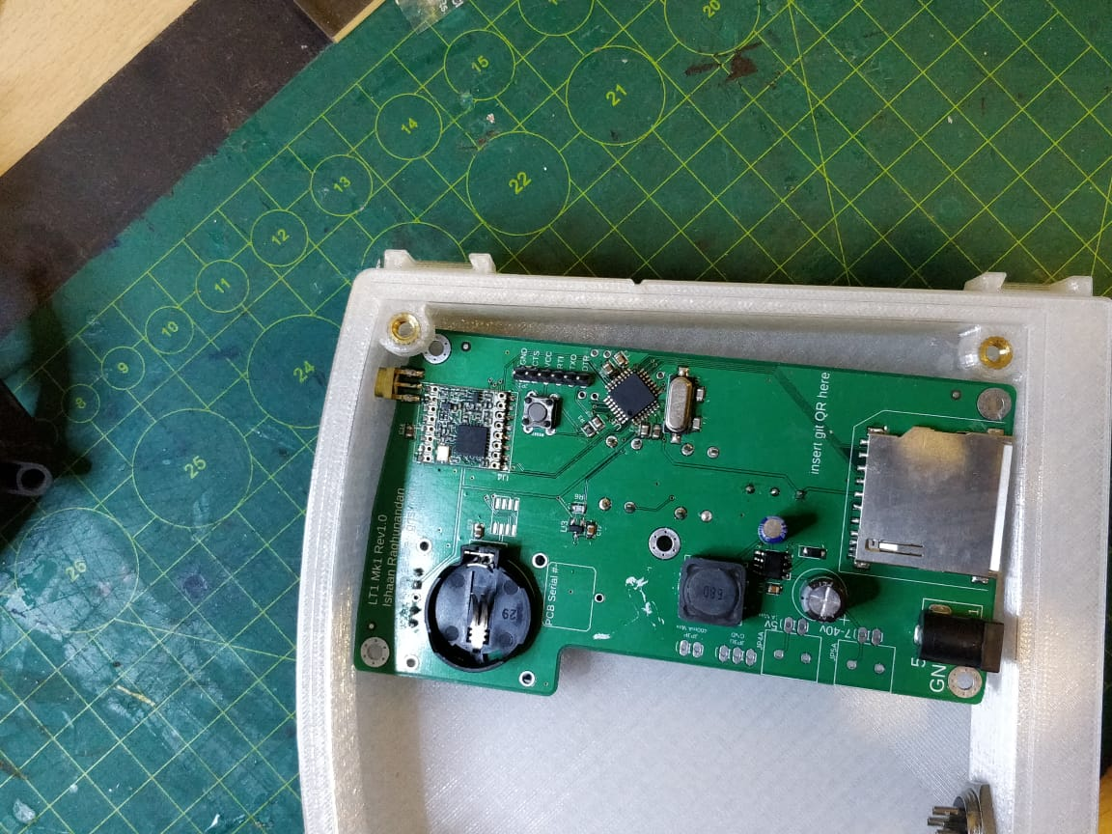

1. Use 4x M3x6 screw to secure PCB into place, and 1x M3x12mm screw in the centre.
2. Check that buttons can be pressed and the switch toggled.

# Acrylic Cover Assembly Order

1. Take 10 m4x15 bolts, slide rubber washers into place.
2. Take 3 A4 e-clips and use a pair of pliers to gently squeeze them tighter. Opening needs to reduce by about 1mm, but don't stress about it.
3. Take port and button covers, insert 3x prepped m4 bolts into place. Note port orientation
4. Use pliers to press 3x e-clips into place to retain the bolts.
5. Finally, Peel off acrylic protection.

# Exterior application assembly notes

1. Apply a firm but gentle amount of torque while tightening the bolts. Overtightening will compromise the inserts or prints.
2. All M4 bolts can be used with a Rubber washer to increase water resistance, although care must be taken to prevent Rubber washer squeeze out. Ideally, 1mm rubber washers can be used instead, as they do not require any sealing fasteners.
3. Consider adding a dot of CA glue to the edges of the brass inserts once they are assembled, to gap-fill.
4. The 16mm Roundshell connectors can be further secured with a drop of superglue between the metal and plastic components. Care must be taken to avoid marring the threads.
5. Ensure all CA glue joints are properly ‘wetted’ during assembly, to prevent leaks.
6. Consider using a single part silicone gasketing sealant on main external joints, especially around the SMA connector’s port after the device is assembled and the antenna fixed.